
12/2025
13 July 2025
MEDIA RELEASE

CESSNA CARAVAN 208B AIRCRAFT, P2-AMH, ABNORMAL RUNWAY CONTACT DURING LANDING AT BALIMO, WESTERN PROVINCE, PAPUA NEW GUINEA.
The PNG Accident Investigation Commission (AIC) commenced an investigation into an accident that occurred today involving a Tropicair Limited Cessna Caravan 208B aircraft, registered P2-AMH, at Balimo Airstrip, Western Province, Papua New Guinea.
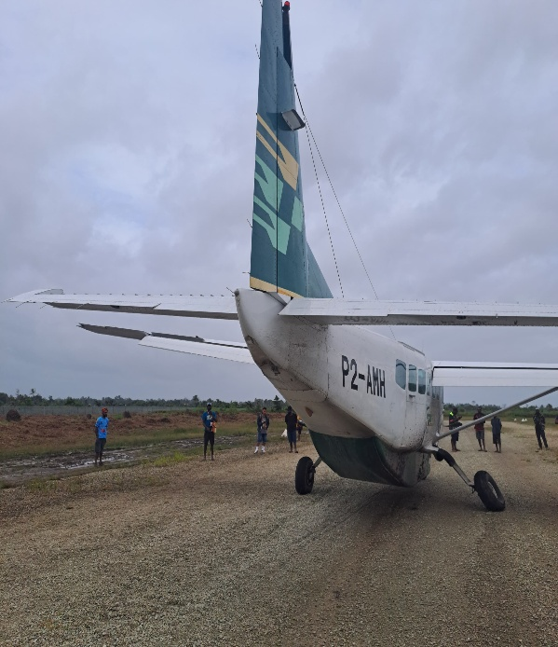
The AIC was notified of the occurrence by Tropicair Limited via an email at 14:53 on 13 July 2025.
From initial information gathered, the aircraft was on a charter flight from Port Moresby’s Jacksons International Airport to Balimo Airstrip, when during touchdown at Balimo Airstrip, the aircraft experienced a hard landing. The event was reported to have occurred at about 14:15 local time.
There were nine (9) persons on board; one (1) pilot and eight (8) passengers, with no reported injuries.
AIC’s assessment of the information showed that the aircraft sustained substantial damage to the Nose Landing Gear, Right Main Landing Gear and Propeller Blades. There was also minor damage to the aft of the empennage.
The AIC will be deploying a team of investigators to the accident site tomorrow to conduct onsite investigation activities.
The occurrence has been classified as an ‘Accident’ and will be conducted in accordance with ICAO Annex 13 to the Convention on International Civil Aviation. The investigation will include but not be limited to the Aircraft and Pilot Performance, Airstrip Conditions, Weather, Maintenance and Serviceability of the aircraft, Organisational Aspects and Regulatory Oversight.
The AIC’s investigations are conducted independent of any other agency or person for the sole purpose of determining the circumstances and contributing factors so that vital lessons are learned, and similar occurrences are avoided.
More information about this investigation can be found at www.aic.gov.pg

Authorised for release by:

Maryanne J. Wal
Chief Commissioner

