
02/2026
16 January 2026
MEDIA RELEASE

ATR 42-500 AIRCRAFT, P2-KSA, RUNWAY EXCURSION DURING LANDING AT SIMBERI AIRPORT, NEW IRELAND PROVINCE, PNG.

The Papua New Guinea Accident Investigation Commission (AIC) has commenced an investigation into an occurrence involving an ATR 42-500 aircraft, registered P2-KSA, operated by Hevilift Aviation Limited PNG. The occurrence took place during landing at Simberi Airport in New Ireland Province on 15 January 2026, at about 4:30 PM local time.
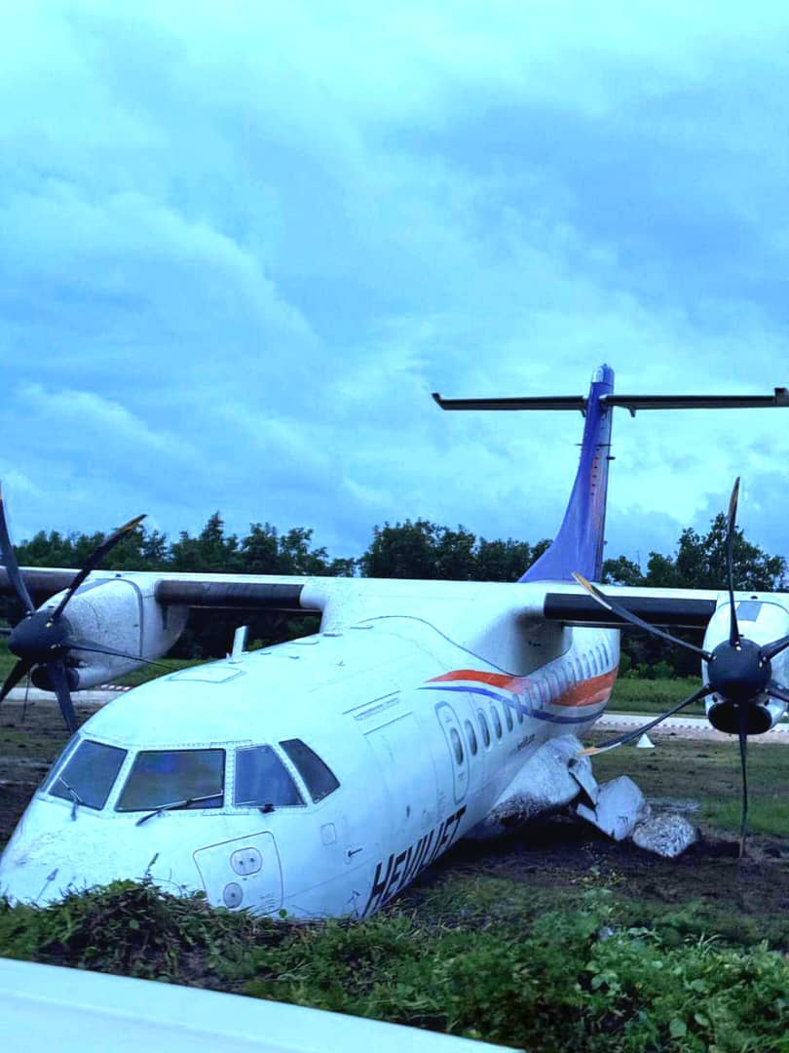
The AIC was notified of the serious incident by Niusky Pacific Limited at 7:19 PM on the day of the occurrence.
Figure 1: Image of P-KSA in its resting position post-occurrence. (Source: BEA)
From initial information gathered and assessed, the AIC has classified the occurrence as a serious incident. The aircraft is reported to have sustained damage following a runway excursion during the landing roll.
There were fourteen (14) persons on board;11 passengers and 3 crew members. There were no reported injuries.
A team is being dispatched today to conduct onsite investigations activities.
This investigation will be conducted in accordance with Annex 13 to the Convention on International Civil Aviation. The occurrence may be reclassified following the AIC’s on-site assessment.
The investigations will include but not be limited to the Aircraft systems and performance, human factors, Airstrip Conditions, Weather, Maintenance and Serviceability of the aircraft, Organisational Aspects and Regulatory Oversight.
The AIC’s investigations are conducted independent of any other agency or person for the sole purpose of determining the circumstances and contributing factors so that vital lessons are learned, and similar occurrences are avoided.
More information about this investigation shall become available in due course on www.aic.gov.pg
Authorised for release by:
Maryanne J. Wal
Chief Commissioner

